**Project name: Healthfirst Care initiative**

**Risk Mitigation Plan**

This Risk Mitigation Plan identifies potential risks associated with the healthcare process optimization project. It outlines mitigation strategies to minimize risks and contingency plans to handle unexpected issues, ensuring smooth project execution.

**Mitigation Strategies (Detailed) for High Risk Level-**

**Implement Strong Encryption**Use special codes (encryption) to protect patient data so that no one can read it except authorized people. Also, keep passwords strong and change them regularly.

**Regular Maintenance of System**Regularly check and update the hospital’s software and computers. Fix any small issues early so they don’t become big problems later.

**Conduct Training Sessions & Offer Incentives**Arrange regular, simple training for staff to help them learn the new system. Motivate them by offering rewards like certificates, appreciation, or small bonuses.

**Use Agile Methodologies**Break the whole project into small parts and complete them one by one. Review each part before moving forward. This helps catch mistakes early and avoid delays.

**Conduct Phased Integration with Backup Plans**Instead of changing everything at once, introduce the new system in small steps. If any problem happens, go back to the older system until the issue is fixed.

**Arrange Necessary Training and External Support**Organize workshops or short courses for the IT team to improve their skills. If needed, hire external experts for help during difficult technical tasks.

**Contingency plans-**

|  |  |
| --- | --- |
| **Risk ID** | **Contingency Plan** |
| **R1** | |  | | --- | | In case of a breach, isolate affected systems, inform IT, conduct root cause analysis, apply fixes. | |
| **R2** | |  | | --- | | If downtime happens, switch to manual processes, activate backups, and inform IT to restore quickly. | |
| **R5** | |  | | --- | | If staff still resist, assign peer mentors/champions, conduct open Q&A, adjust training style. | |
| **R6** | |  | | --- | |  |  |  | | --- | | If delayed, activate buffer time, focus on priority tasks, notify management, and escalate blockers. | |
| **R8** | |  | | --- | |  |   If failure happens, roll back to stable version, isolate issue, and reattempt with improved checks. |
| **R10** | If skills gap is critical, hire external experts temporarily, provide fast-track training internally. |

**Risk Matrix (Updated)-**

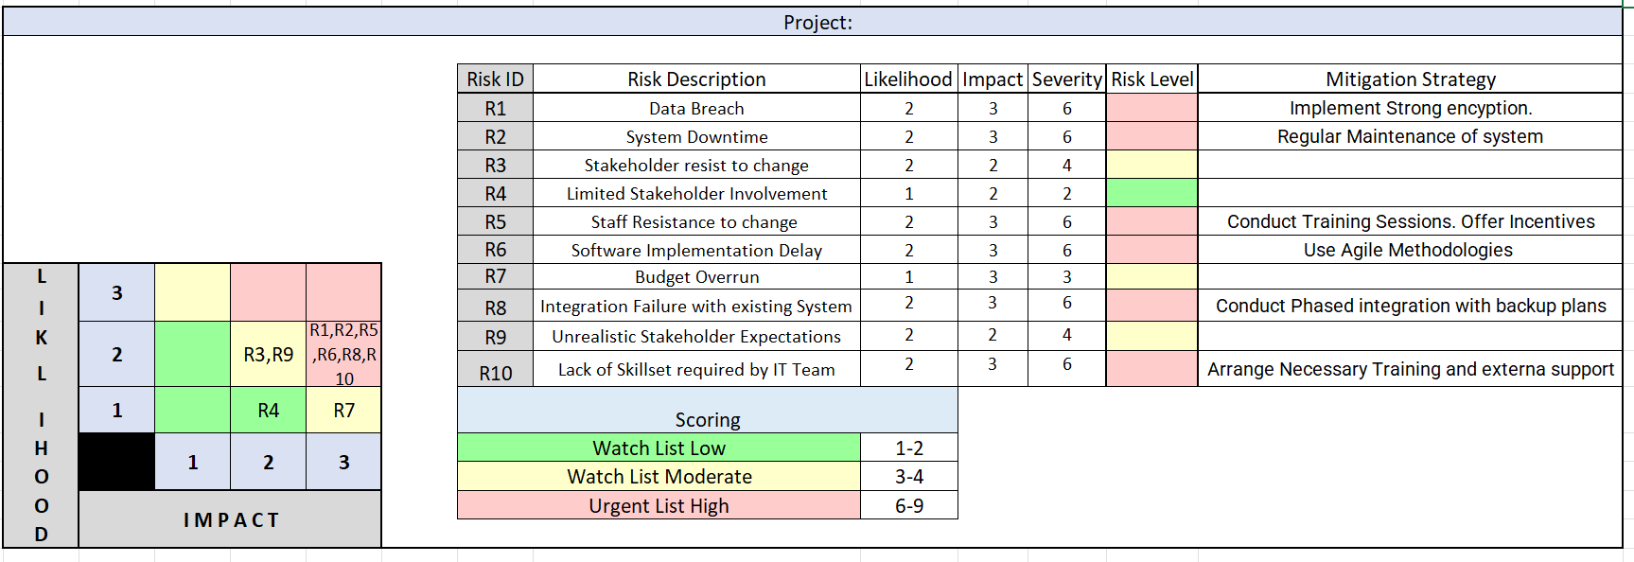

**Key Insights from Risk Mitigation Plan**

* **High-severity risks** such as data breaches and integration failures require immediate attention.
* **Training and awareness sessions** are crucial to reduce staff and stakeholder resistance.
* **System downtime and delays** can be minimized with regular maintenance and agile implementation.
* **Contingency plans** ensure hospital operations continue even if risks occur.
* **Technical risks** were most common, highlighting the need for strong IT support.
* A **visual risk matrix** helped prioritize risks clearly for better decision-making.